**DAILY ONLINE ACTIVITIES SUMMARY**

|  |  |  |  |  |  |  |  |
| --- | --- | --- | --- | --- | --- | --- | --- |
| **Date:** | **10 June 2020** | | | | **Name:** | **K ISHA HEGDE** | |
| **Sem & Sec** | **4th sem, 2nd year** | | | | **USN:** | **4al18cs031** | |
| **Online Test Summary** | | | | | | | |
| **Subject** | | **OBJECT ORIENTED CONCEPTS (18cs45)** | | | | | |
| **Max. Marks** | | **30** | | **Score** | | **14** | |
| **Certification Course Summary** | | | | | | | |
| **Course** | **1. PYTHON. 2. MARKETING FOUNDATION.** | | | | | | |
| **Certificate Provider** | | | **GUVI & great learning** | **Duration** | | | **6 hrs** |
| **Coding Challenges** | | | | | | | |
| **Problem Statement:2 program** | | | | | | | |
| **Status: Executed** | | | | | | | |
| **Uploaded the report in Github** | | | | **Yes** | | | |
| **If yes Repository name** | | | | [https://github.com/iishaii/locked-down_coding](https://github.com/iishaii/locked-down_coding" \o "https://github.com/iishaii/locked-down_coding)  [https://github.com/iishaii/Daily_report](https://github.com/iishaii/Daily_report" \o "https://github.com/iishaii/Daily_report)  <https://github.com/keertanaganiga/lockdown_reports> | | | |
| **Uploaded the report in slack** | | | | **Yes** | | | |

**Online Test Summary**

**Today OBJECT-ORIENTED CONCEPTS (18cs45) was conducted for 30 marks.**

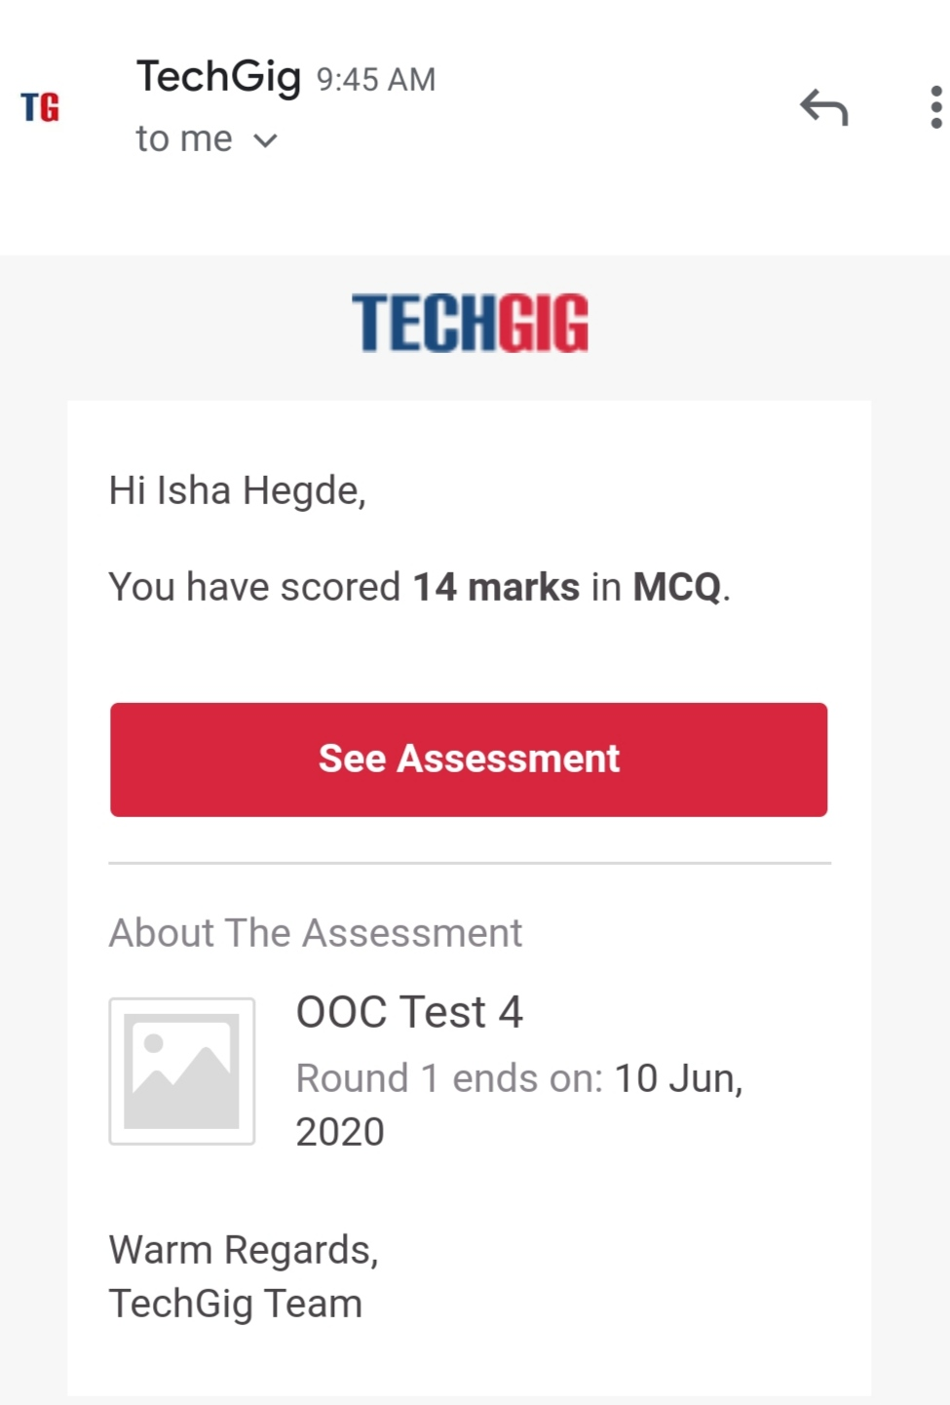

**Certification Course Summary:** **Today I started new certificate course through GUVI, The total duration of the course 'PYTHON' is 26 hrs. Today I completed the beginners module and after each topic , I attempted the quiz which gave me clear veiw about the topic.**

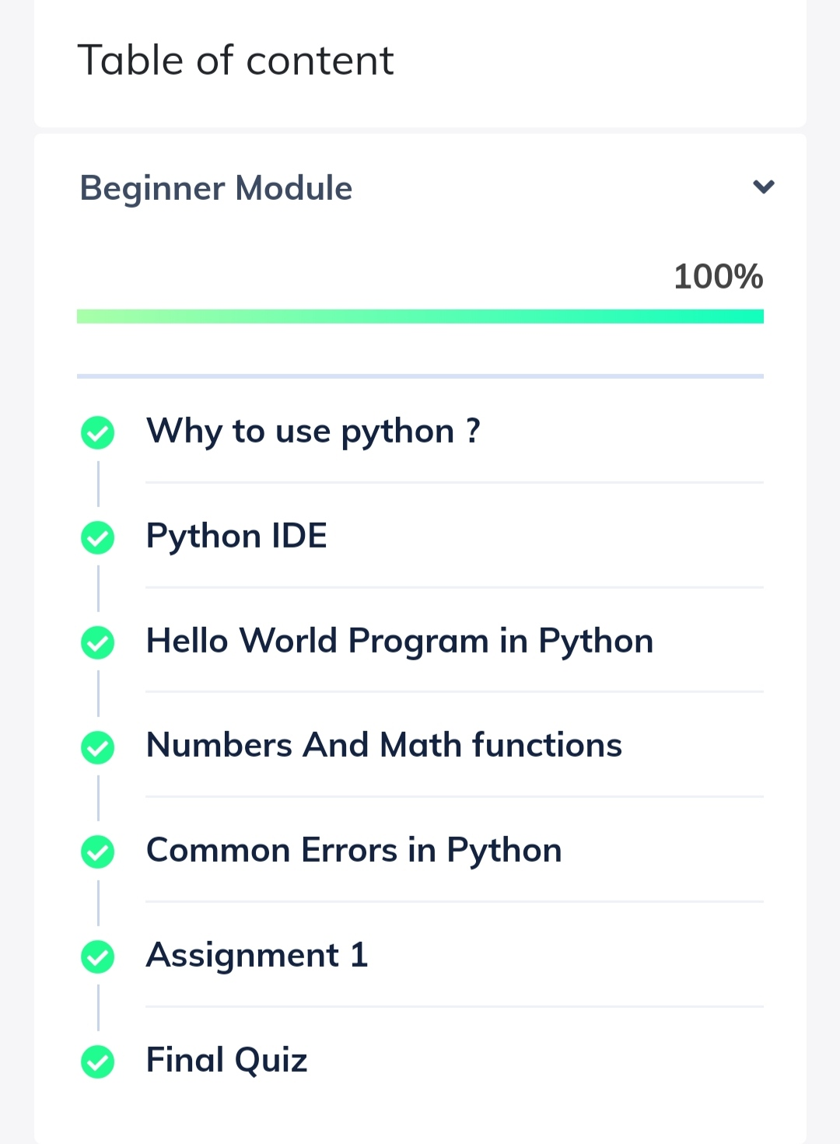

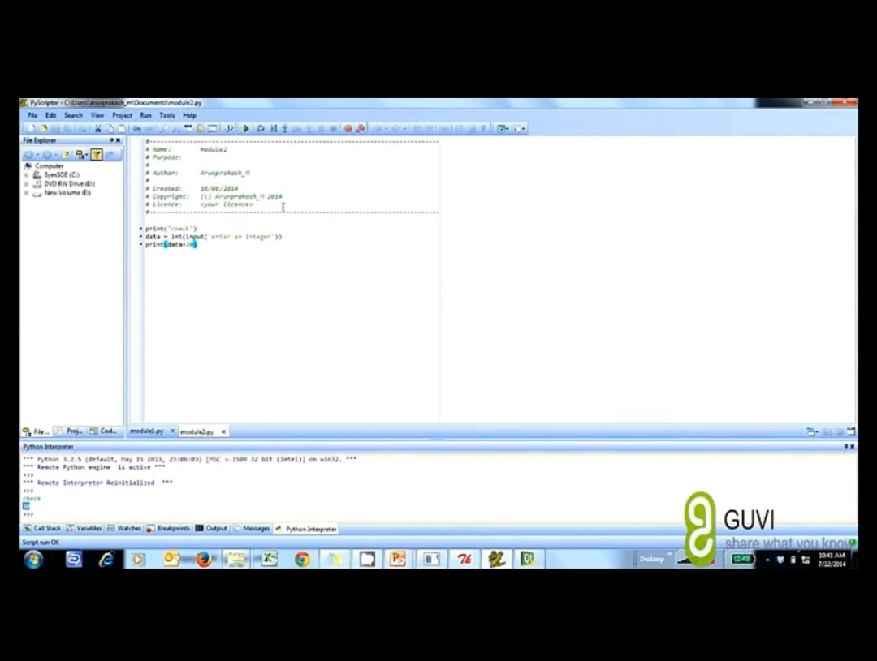

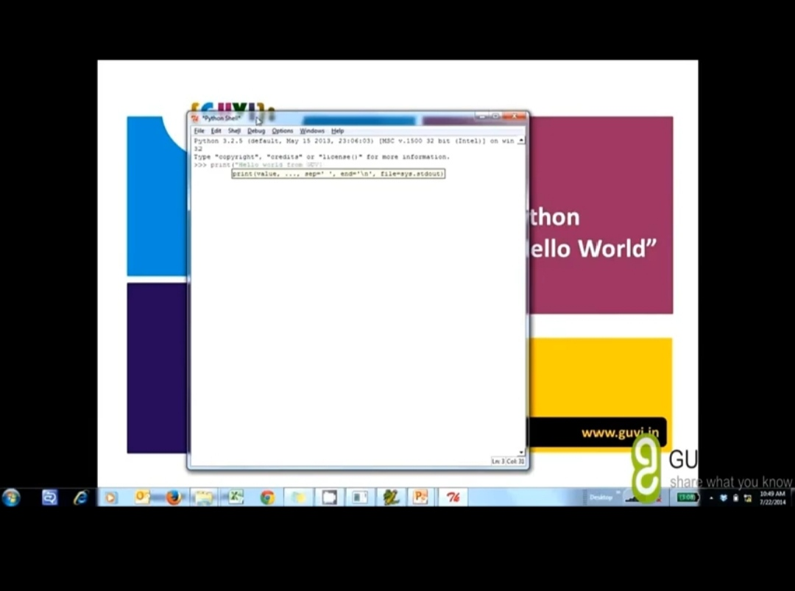

I also completed the MARKETING FOUNDATION course from GREAT LEARNING and today I attempted the quiz, which gave me a clear veiw about the topic and secured a certificate on completion of course.



I attended a webinar on BRAIN CONTROLLED ROBOT DESIGN which was hosted my NITK- STEP in association with PANTECH on 6th of June and today I received the certificate for participation.



**Coding Challenges:**

Today I solved 2 coding challenge,

1. **Java Program to find the longest repeating sequence in a string**

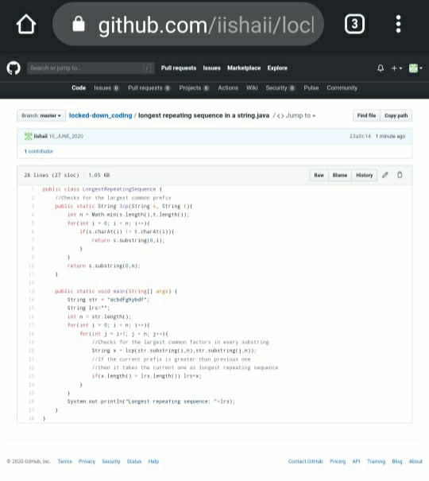

1. **Write a C Program to print the sum of boundary elements of a matrix**

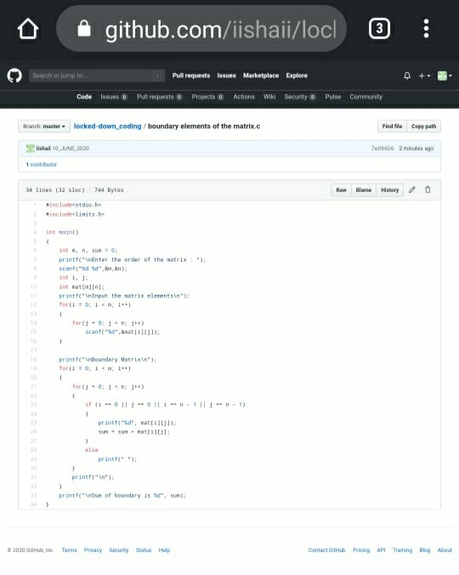

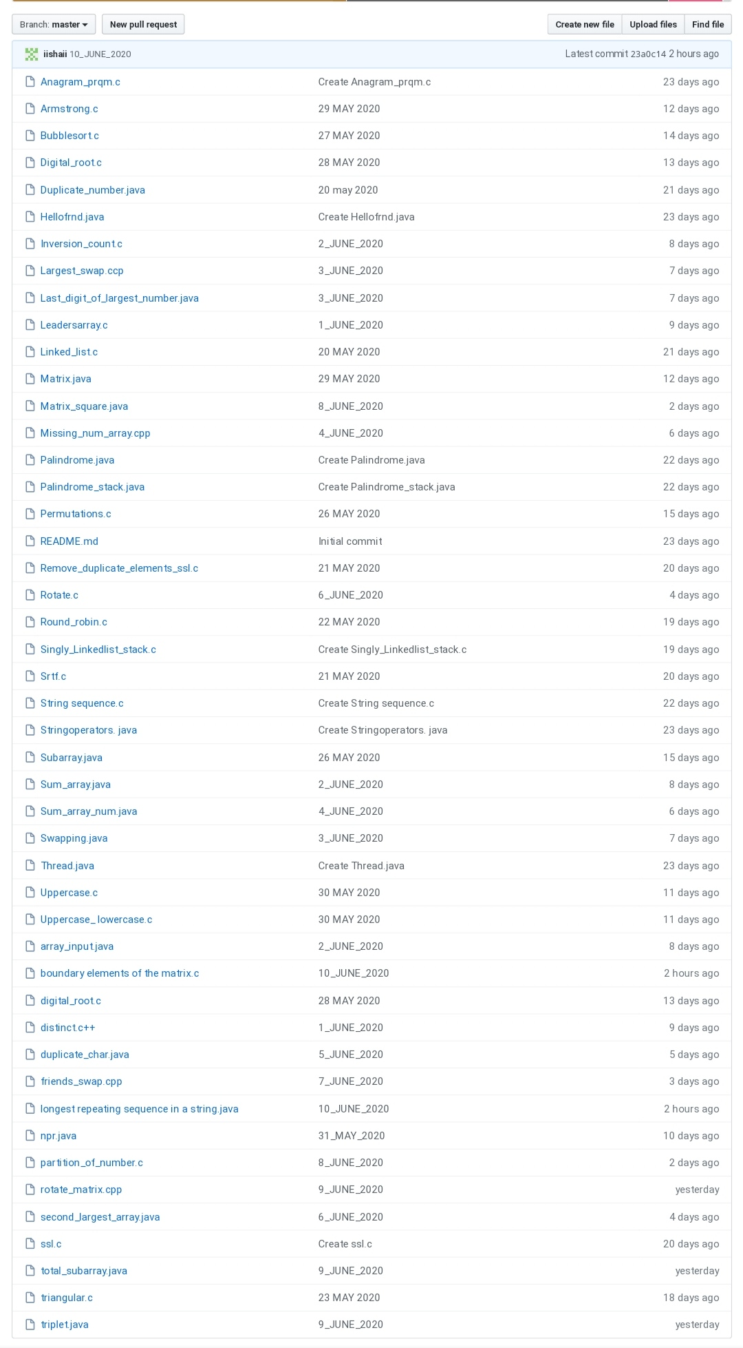

I have uploaded the solution in the github.

[https://github.com/iishaii/locked-down_coding](https://github.com/iishaii/locked-down_coding" \o "https://github.com/iishaii/locked-down_coding)

[https://github.com/iishaii/Daily_report](https://github.com/iishaii/Daily_report" \o "https://github.com/iishaii/Daily_report)